Joel Bell laptop build which went to Jake Iti (17/06/2020)

Asset Number: 111709 (Bulk order - accountants will have reissued a new asset number – unknown what the number is)

New Dell serial number: D7T8L33

No email trail on this ticket

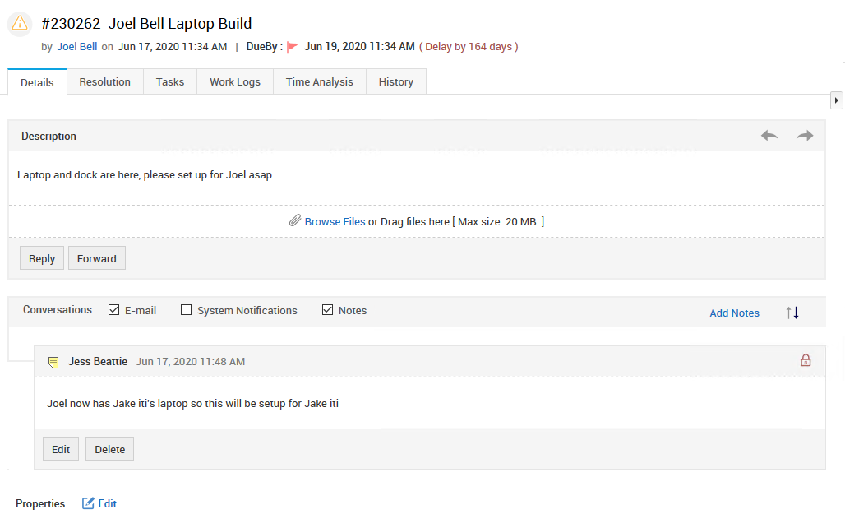

Jake Iti laptop build which went to Joel Bell (5/06/2020)

Asset Number 111801

New Dell serial number: 56yzl33

A long email trail on this ticket – including an email from Scott White on 11/06/2020 asking for the laptop to go to Joel Bell instead and he would get the asset numbers changed.

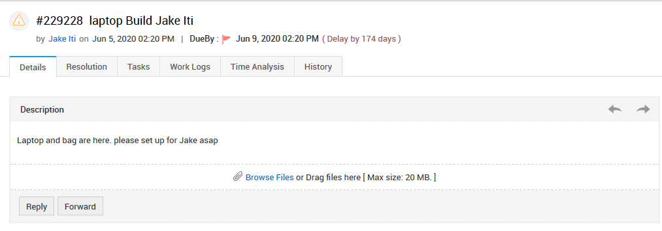

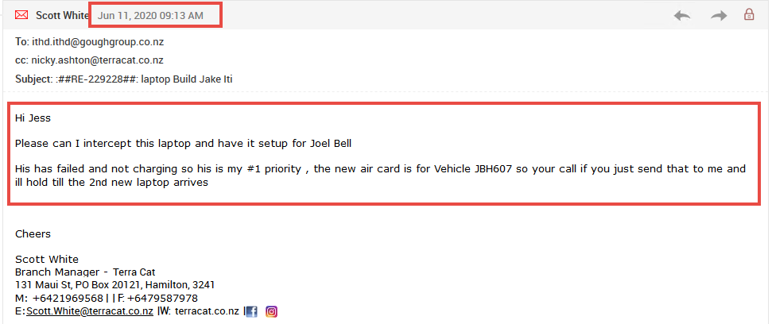

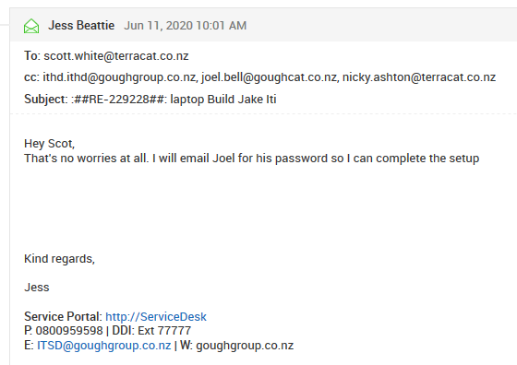

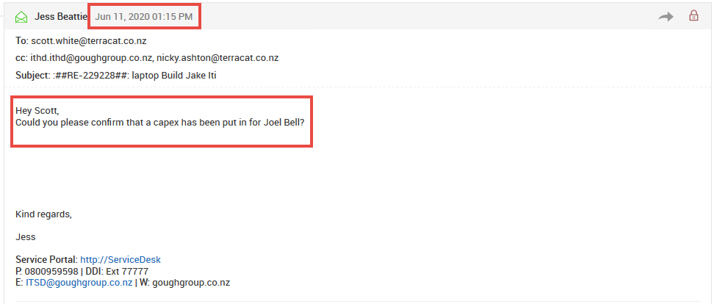

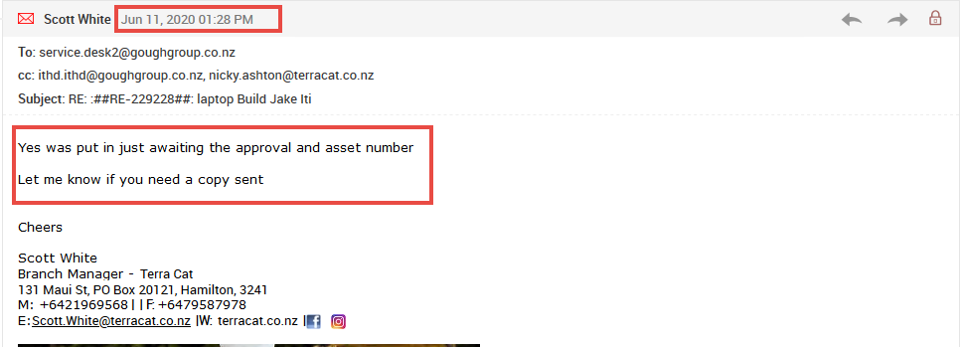

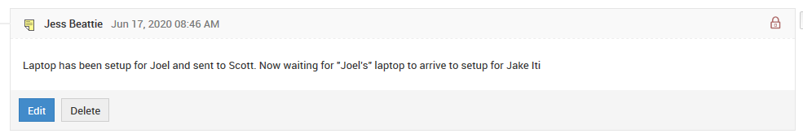

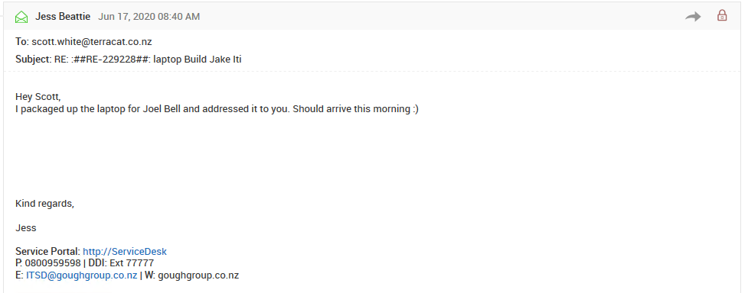

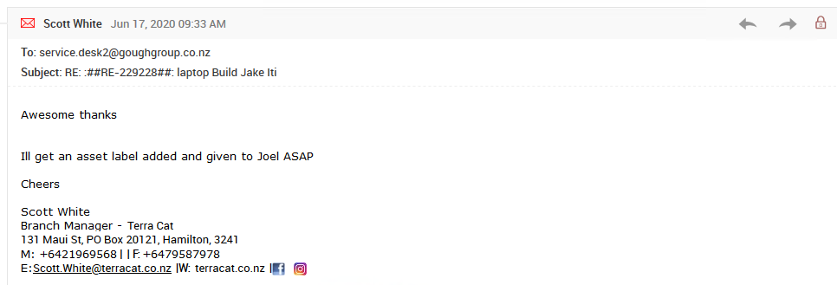

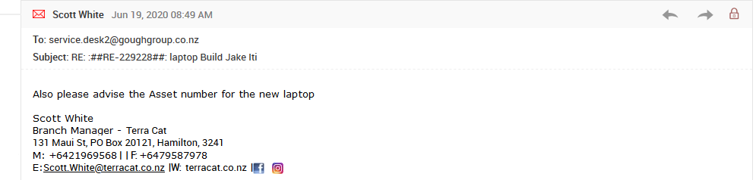

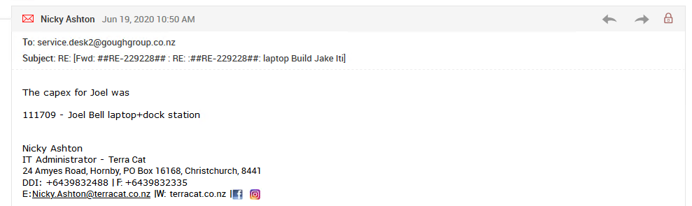

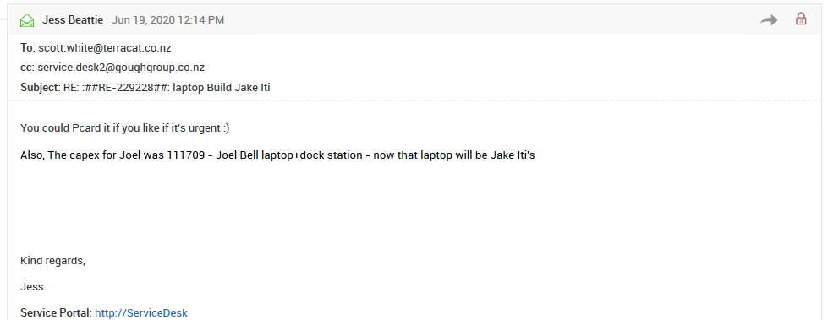

18/09/2020

Jake Iti having issues with an HP laptop – for some reason he wasn’t using his new Dell.

Email from Steph to Jake on 21/09/2020 asking why he isn’t using his new allocated Dell laptop:

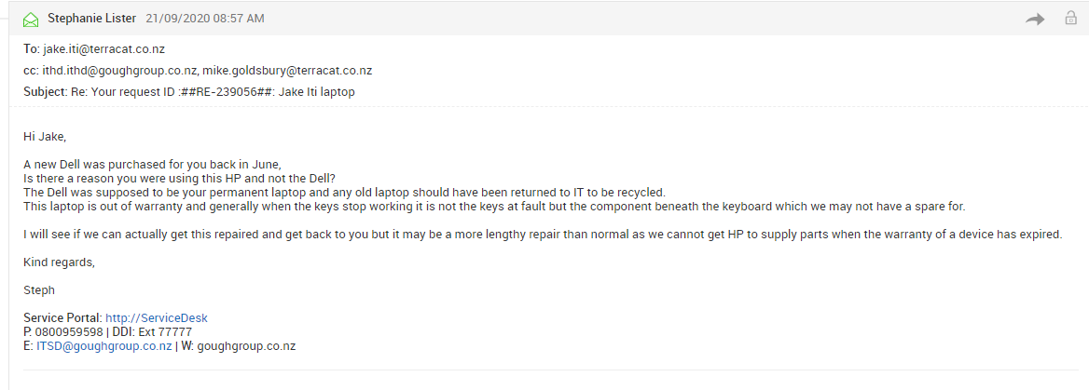

Email reply from Scott:

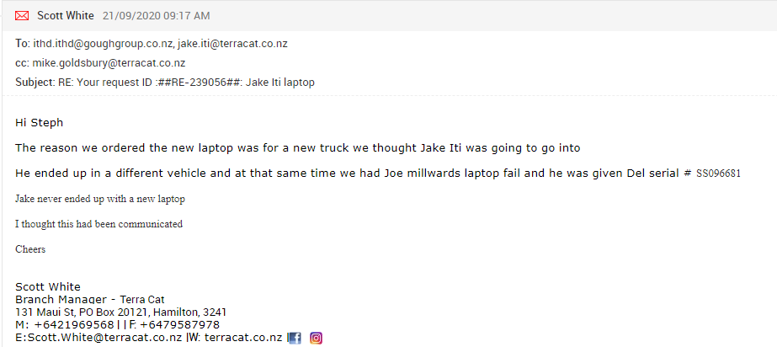

There has been no mention of Jake not receiving the laptop.

16/10/2020 – ticket 241590

New ticket from Jake Iti saying his HP laptop is being sent down as it won’t turn on (again, not sure why he isn’t using the new Dell)

Serial Number of broken HP: 5CG721610V

Gets stuck on the boot up loading screen

Have tried 3 times to rebuild but does the same thing – gets stuck on loading

Emailed Jake saying to put in a capex for a new one:

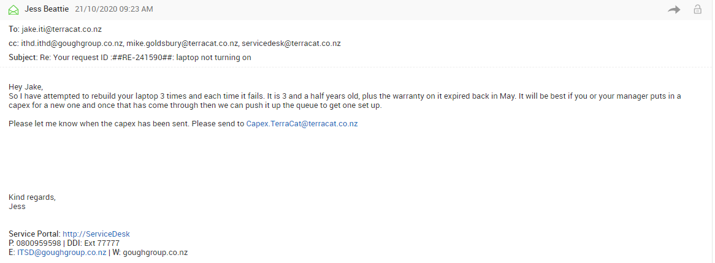

Capex was then put through from Scott

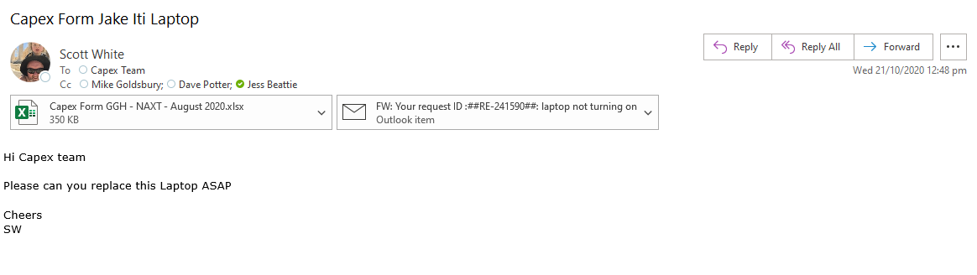

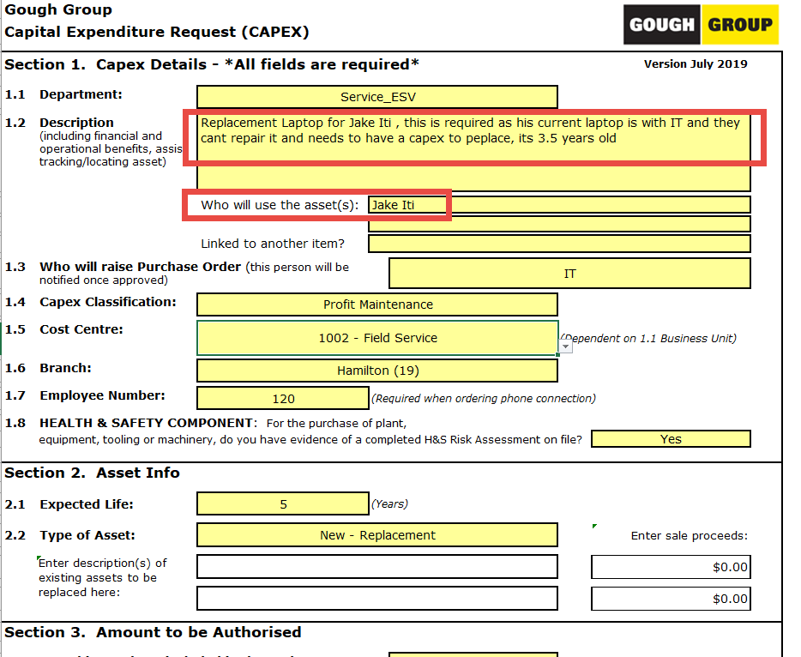

Since the capex was sent through, these are the emails between Scott and Nicky

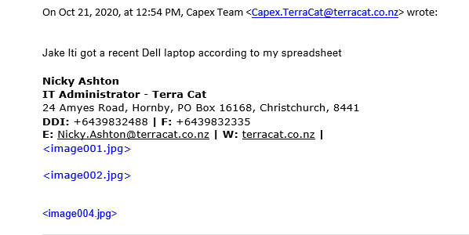

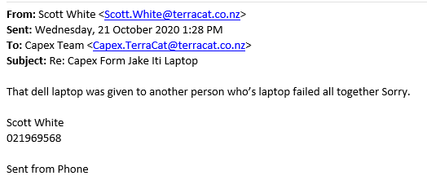

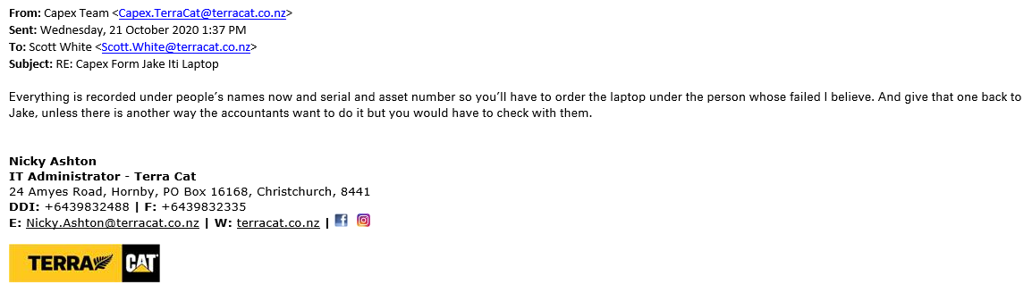

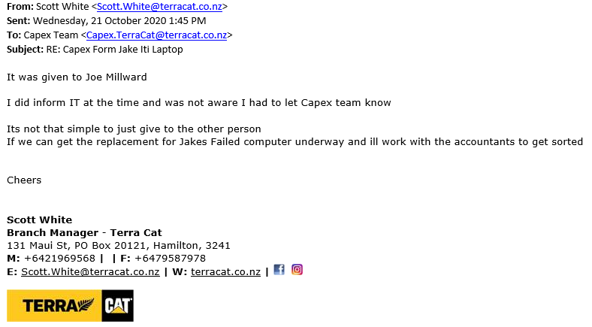

Overall, I cannot find anything that mentions about Jake’s laptop being given to Joe Millward. Now we have another capex for Jake Iti which Nicky isn’t going to process as there has already been one for Jake. This one would probably need to be for Joe Millward and the one he has needs to go back to Jake.